SW 3 - Hamming Code

Jonathan Schwartz

Section 003L

TA: Conner Rickermann

Date submitted: 3/15/2021

**Full Circuit**

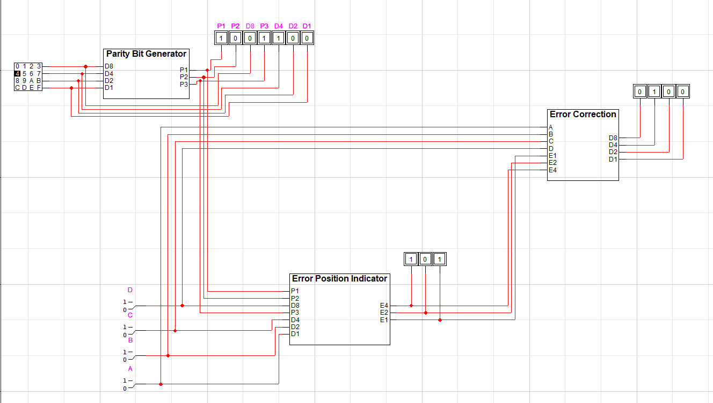

**Parity Bit Generator**

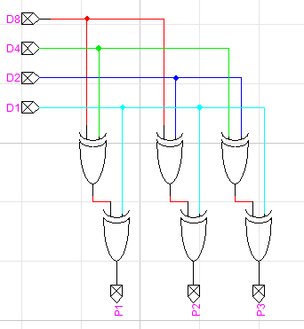

**Error Position Indicator**

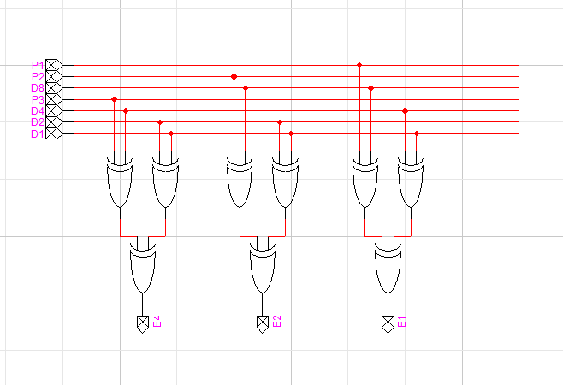

**Error Correction**

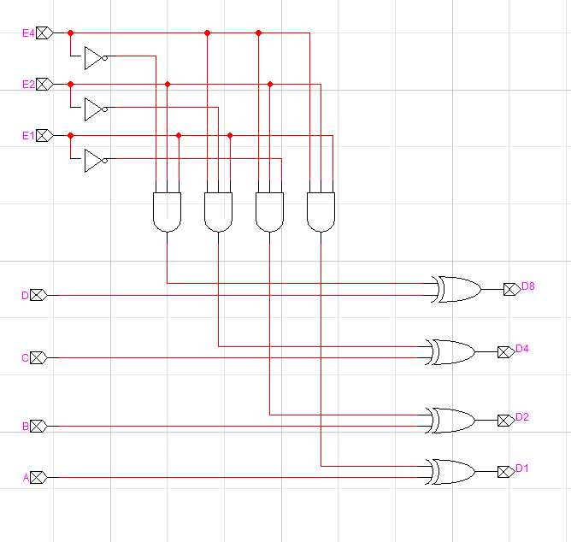

**Questions:**

**1)**

**Graph of Parity Bits Required (y) for Number of Data Bits (x)**

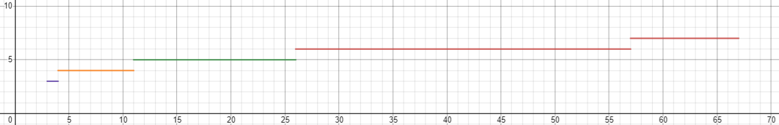

This graph is based on the function that defines the number of parity bits required for number of data bits: 2y≥y+x+1, where y is the number of parity bits required and x is the number of data bits.

**2)**

There could be a parity bit implemented to check the parity of the entire message as a whole, rather than subsets of the bits. This could detect double errors, but it could not *fix* these double errors.

**3)**

The Hamming Distance of two messages is the minimum number of bit flips to turn one into the other. For example, the Hamming Distance of 1111111 and 0000000 is 7, while the Hamming Distance of 1010111 and 0110111 is 2 because only the first two bits are flipped.